Game is node controlled(including parent-child transformations)

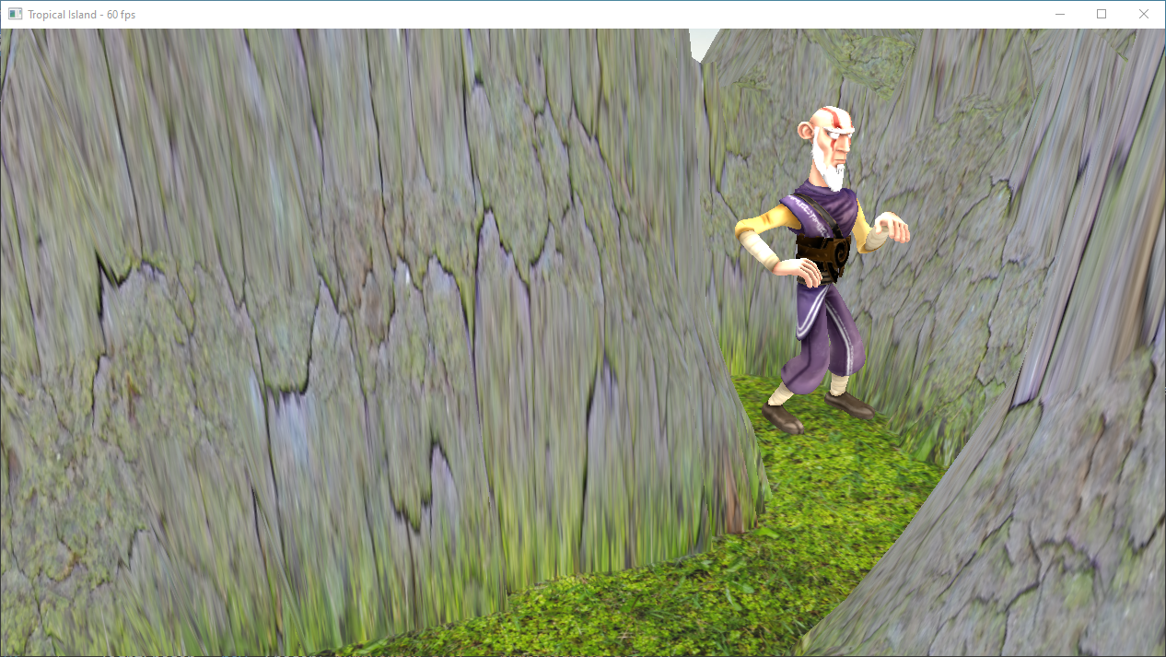

Animation with lighting(as do other objects). Multitextured terrain with the help of normal.

Sp. Effect – press 1

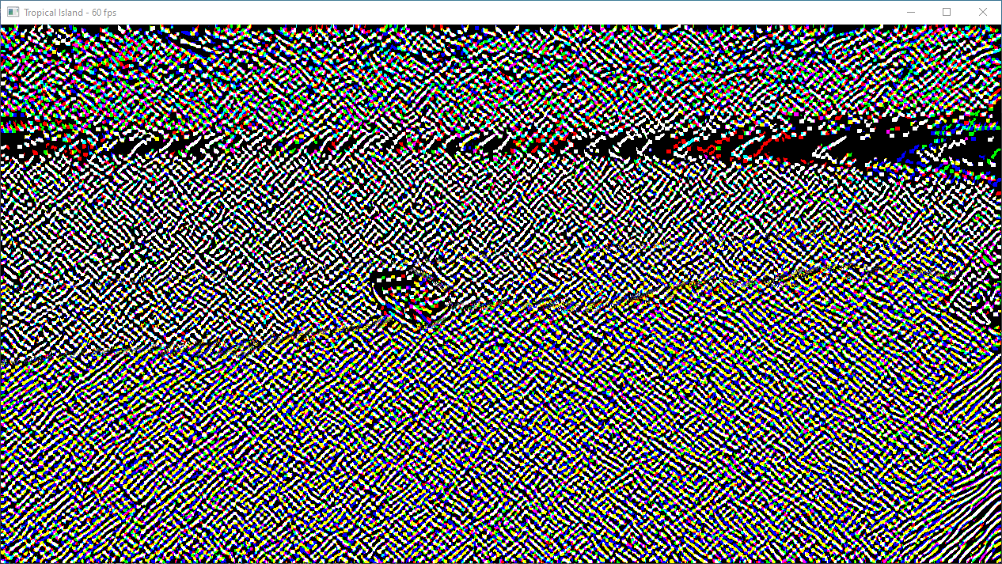

Blur – press 2

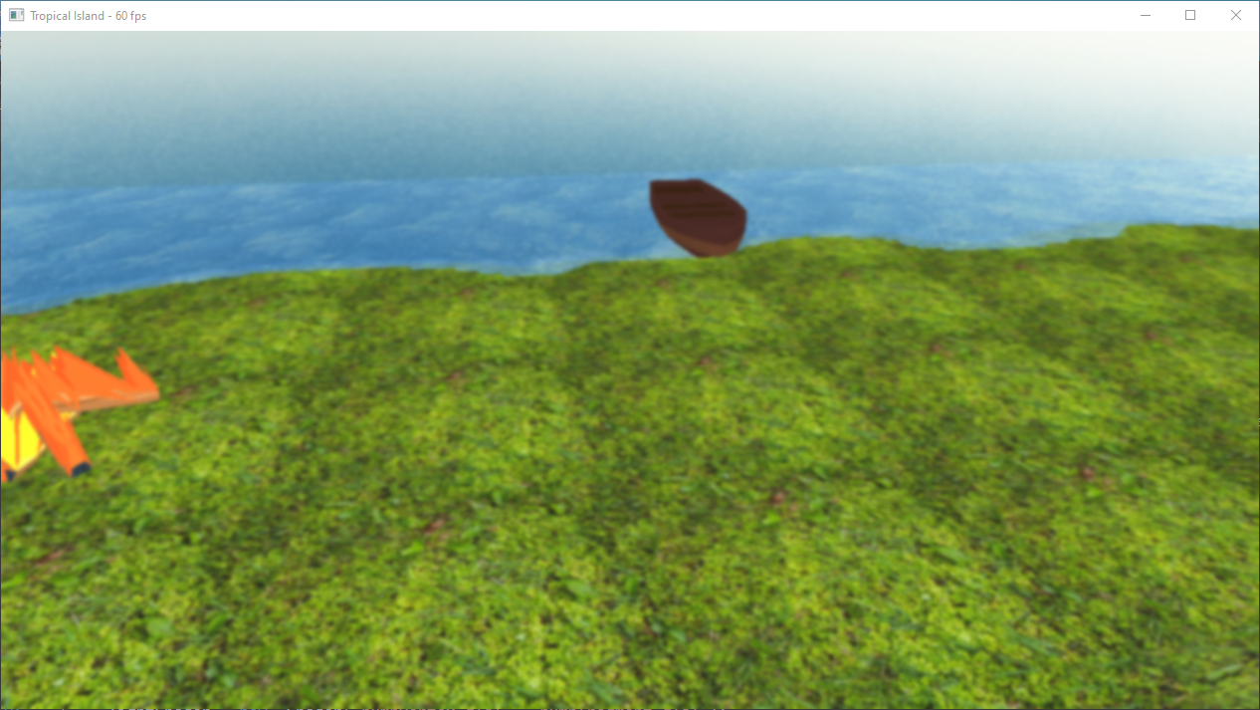

Bloom – press 3

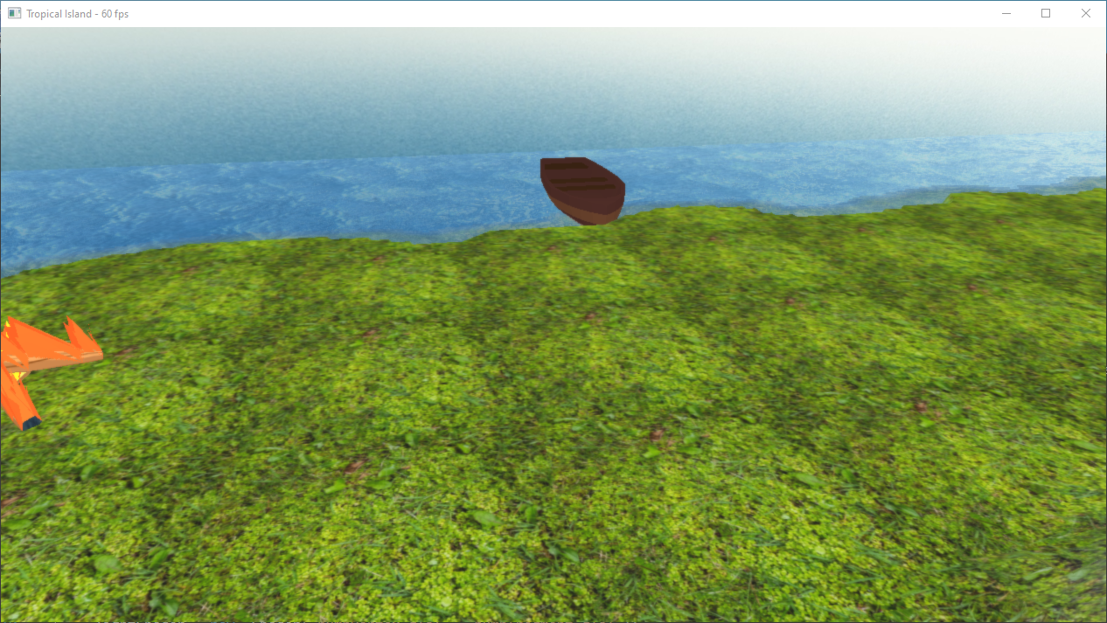

Press 0 to remove any post processing effect.

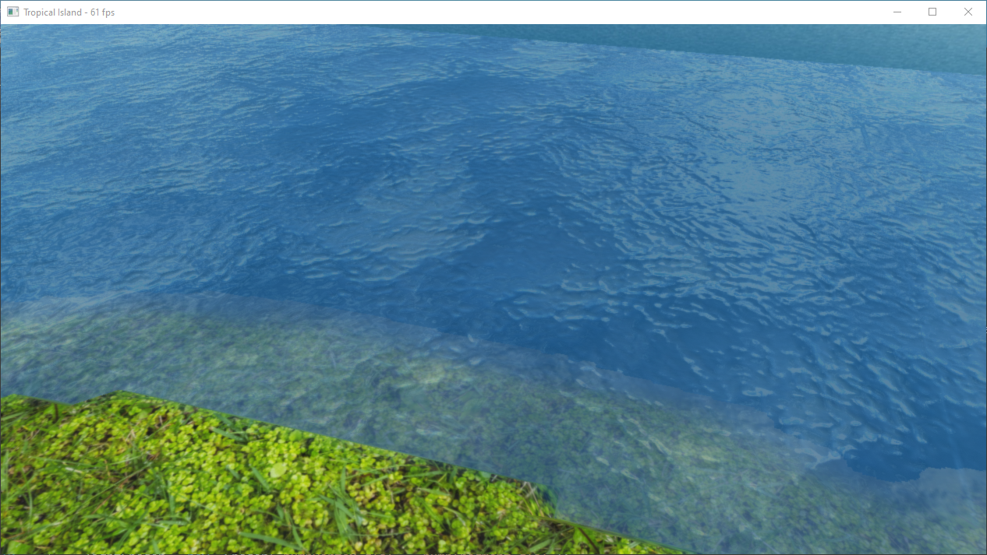

Transparent water with cubemap texture blended and bumpmap added and reflection.

Scene Node correctly sorts and manages transparent objects.

Geometry shader & particle effect

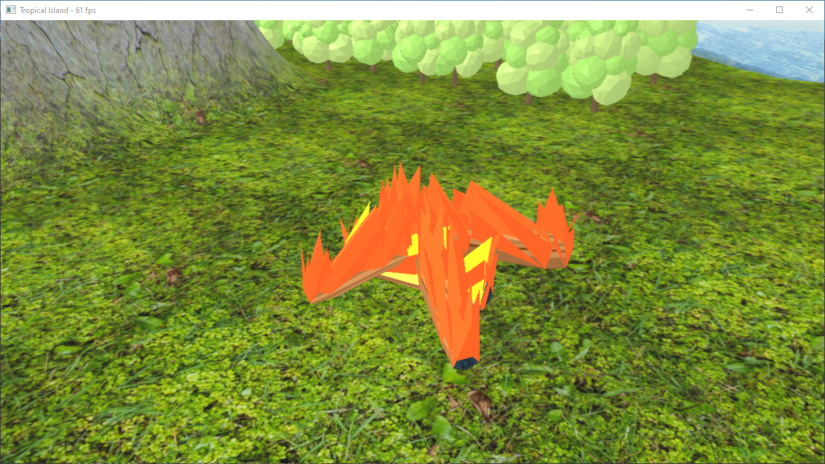

ToggleFire(F)

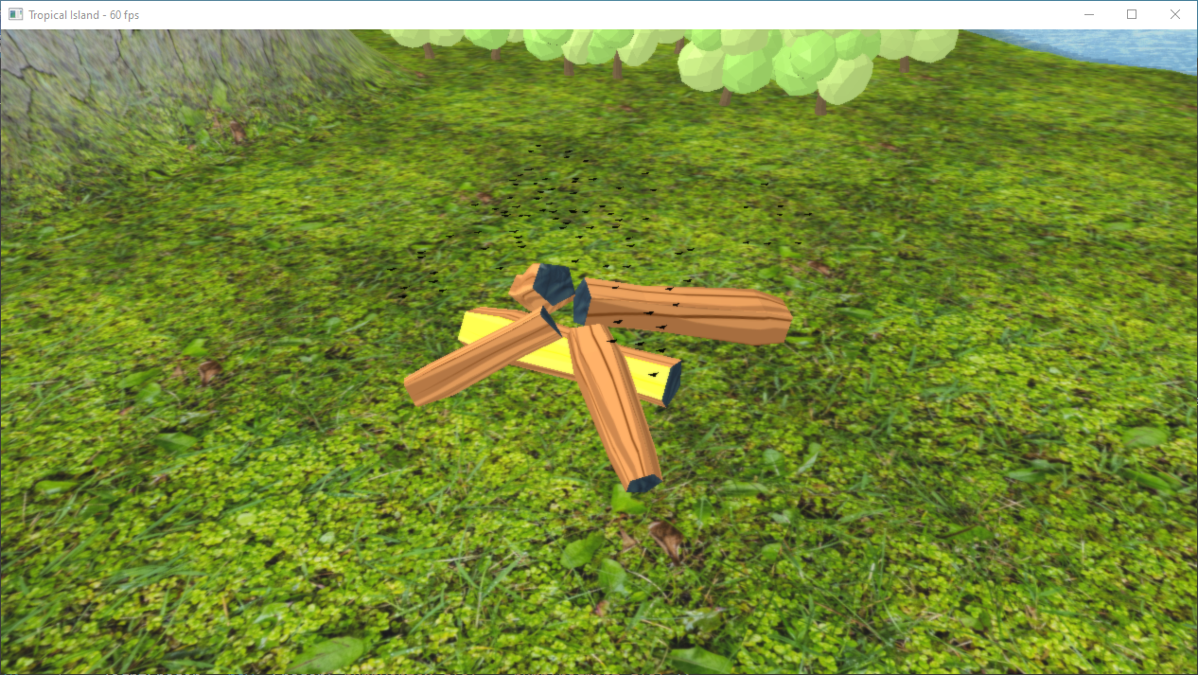

ToggleSmoke(F)

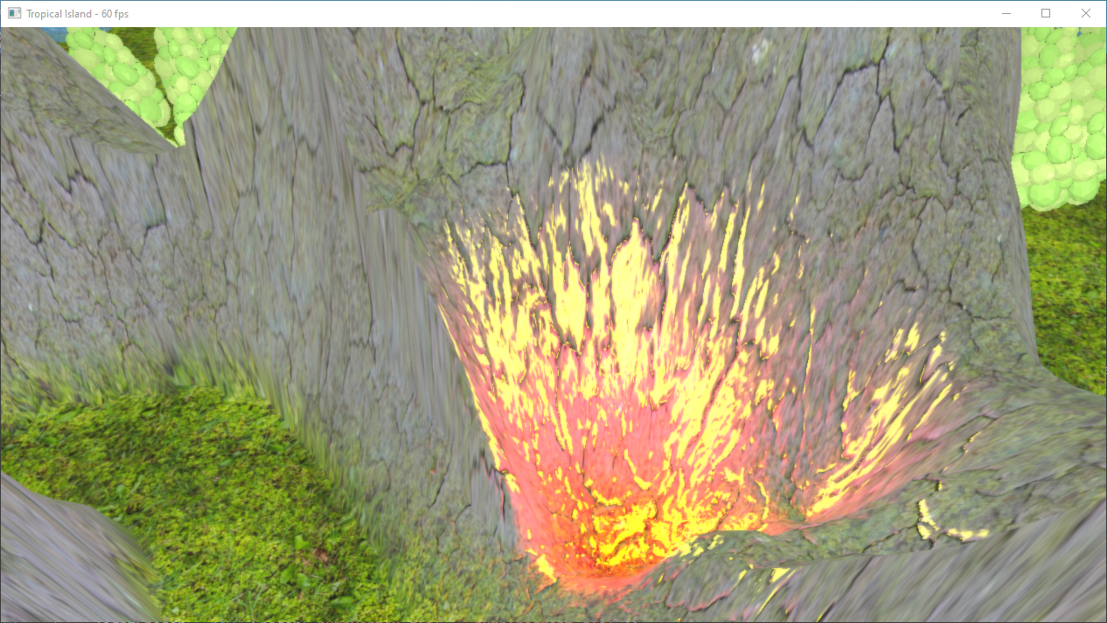

Volcano effect via another point light.

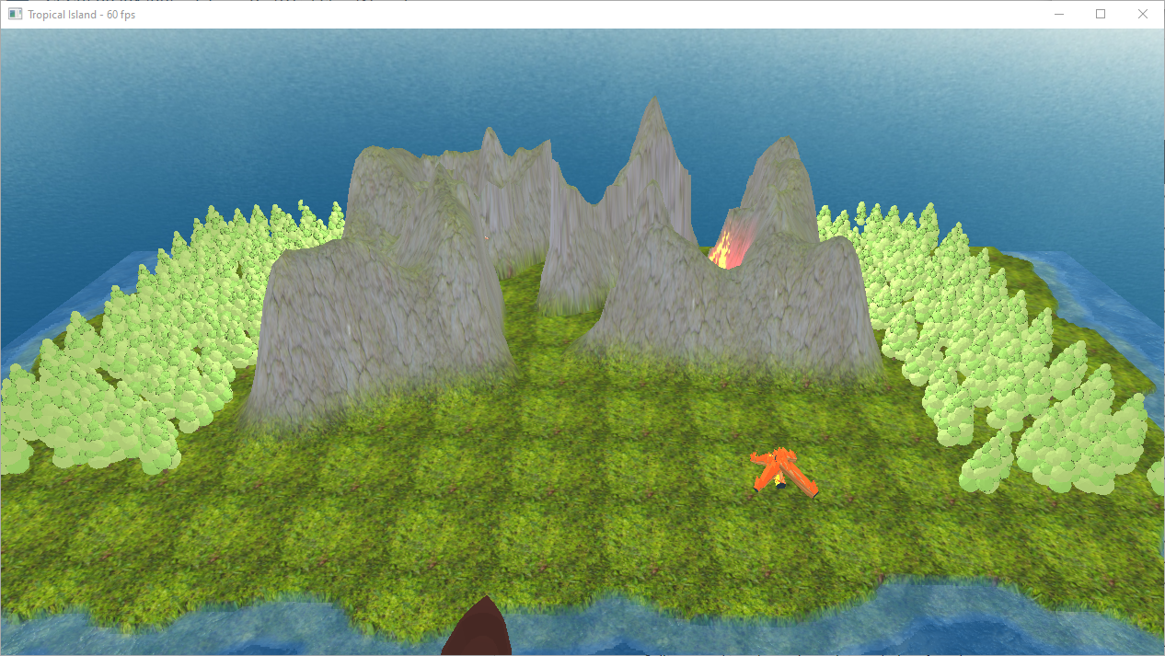

Trees are procedurally placed randomizing their position & rotation.

Fully automated camera movement.

Frame Rate – 60FPS.

Video Link: <https://youtu.be/5v9N2c_jTnY>